Quick Reads and Reading Ahead materials
Learning & Organising Services has a collection of Quick Reads to help branches promote literacy and reading groups. You can also order Reading Ahead materials.
Please fill in your details and indicate which resources you would like.

Contact Clair Hawkins: c.hawkins@unison.co.uk with requests and queries

Name:

UNISON role:

Branch and Region:
Address for postage:

Email:

Tick to confirm UNISON can pass your details to the Reading Agency which provides helpful information and updates about Quick Reads, Reading Ahead and book groups.

How do you plan to use these books and materials? Please note we will also require you to report back on how you get on.

Reading Ahead 2018/19
Reading Ahead invites people to pick six reads to record and review.
Quantity
Reading Ahead diaries
Reading Ahead certificates
Reading Ahead posters
Reading Ahead bookmarks

Quick Reads will be dispatched once a month from UNISON’s storage centre. Ensure your order is received by 1st of the month for dispatch that month.

Quick Reads and UNISON’s writing competition booklet:
 | Title |  | Quantity
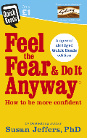 | Feel the Fear and Do it Anyway by Susan Jeffers | A specially adapted book drawing on the late Susan Jeffers' landmark self-help book Feel the Fear and Do it Anyway and its bestselling follow ups.
 | Today Everything Changes by Andy McNab | Andy McNab's start in life was tough. Growing up with foster parents and surrounded by poverty he attended seven schools in as many years and struggled with reading.  After being recruited into the Army from a juvenile detention centre, his life changed forever.
 | Tackling Life by Charlie Oatway | Tackling Life is the story of how Charlie Oatway managed to turn his life around from petty crime and struggling at school to becoming a professional footballer and inspiring others to succeed.
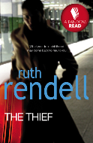 | The Thief by Ruth Rendell | Stealing things from people who upset her was something Polly did.  Her Aunt Pauline; a girl at school; a boyfriend who left her. And then the man on the plane...  Humiliated by a total stranger Polly does what she always does. She steals something. But this time with terrifying results.
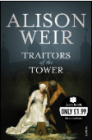 | Traitors of the Tower by Alison Weir | More than four hundred years ago, seven people were beheaded in the Tower of London. Three had been queens of England. The others were found guilty of treason. Why were these people put to death?
 | UNISON writing competition celebration booklet | This booklet celebrates the six winning entries of UNISON’s 2018 writing competition on the theme ‘Learning: past, present, future’. A great read to inspire creative writing and share the power of learning.

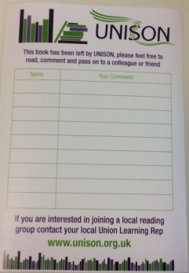
UNISON book stickers
We have UNISON book stickers to record names and comments of people who
borrow and return Quick Reads and other books from UNISON book swap shelves.

I’d like _______ UNISON book stickers.

ULF Kickstart funding of up to £250 may be available to help set up an activity or event. Email kickstart@unison.co.uk to request an application form.

