Quick Reads and Reading Ahead materials
Learning & Organising Services has a collection of Quick Reads to help branches promote literacy and reading groups. You can also order Reading Ahead materials.
Please fill in your details and indicate which resources you would like.

Contact Clair Hawkins: c.hawkins@unison.co.uk with requests and queries

Name:

UNISON role:

Branch and Region:
Address for postage:

Email:

Tick to confirm UNISON can pass your details to the Reading Agency which provides helpful information and updates about Quick Reads, Reading Ahead and book groups.

How do you plan to use these books and materials? Please note we will also require you to report back on how you get on.

Reading Ahead
Reading Ahead invites people to pick six reads to record and review.
Quantity
Reading Ahead diaries
Reading Ahead certificates
Reading Ahead posters
Reading Ahead bookmarks

Quick Reads will be dispatched once a month from UNISON’s storage centre. Ensure your order is received by 1st of the month for dispatch that month.

Quick Reads:
 | Title |  | Quantity
 | This is Going to Hurt by Adam Kay | A junior doctor’s diary written in secret after long days, sleepless nights and missed weekends. Funny, moving and sometimes shocking tales of life on and off the hospital ward.
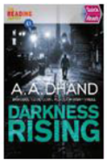 | Darkness Rising by AA Dhand | DI Harry Virdee has a lot on his plate. His team is facing cuts, tensions are building between rival drug gangs and his wife is due to give birth. So when bodies start turning up in the old industrial district, the pressure is on to wrap up the case as quickly as possible.
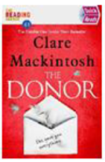 | The Donor by Clare Macintosh | When Lizzie's daughter Meg is given a life-saving heart transplant, Lizzie feels hugely grateful to the nameless donor. Then she receives a letter from the donor's mother asking to meet and it seems like the least she can do. But something isn't right ...
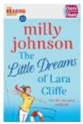 | The Little Dreams of Lara Cliffe by Milly Johnson | Lara Cliffe and her three friends are off on a hen party mini break. It's three weeks before her wedding to kind 'Steady Freddie' but something is worrying Lara. Fifteen years ago Danny Belfont walked out on her three weeks before their wedding. Then, on the overnight ferry Danny spots Lara. If fate has brought them back together... is it really for love or for something quite different?
 | Notting Hill Carnival: A West Side Story by Candice Carty Williams | Sapphire is the leader of Red Roses in an area where gang loyalty is everything. But after a tragic event Sapphire vows to leave her old life, friends and gang behind. When she meets Apollo she feels something she's not felt before and thinks he could be the one ... until she discovers he's a member of a rival gang. Will she ever escape her past and how many lives will be ruined until she does?
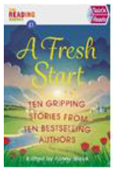 | A Fresh Start - short story collection edited by Fanny Blake | Jojo Moyes, The Makeover; Sophie Kinsella, Decluttering; Ian Rankin, Easy Street ; Mari Hannah, Let No One In; Louise Candlish, Lock Up and Leave; Adele Parks, A Quiet Road; Mahsuda Snaith, The Estate; Mike Gayle, You and Me; Keith Stuart, An Accidental Date; Fanny Blake, Sisters

UNISON writing competition celebration booklet
I’d like _______ UNISON writing competition booklets.

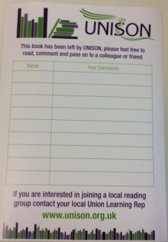
UNISON book share stickers
I’d like _______ UNISON book stickers.

ULF Kickstart funding of up to £250 may be available to help set up an activity or event. Email kickstart@unison.co.uk to request an application form.

